Exercise No:2

Date:15.10.20

Aim: To count the number of occurrences of the element in the given list.

Program:

def countX(lst,x):

count=0

for i in range(len(lst)):

if lst[i]==x:

count+=1

return count

lst=[]

n=int(input())

for i in range(n):

ele=int(input())

lst.append(ele)

x=int(input())

count=countX(lst,x)

print(count)

Link:

[http://103.53.53.18/mod/vpl/forms/edit.php?id=230&userid=1702#](http://103.53.53.18/mod/vpl/forms/edit.php?id=230&userid=1702)

Output:

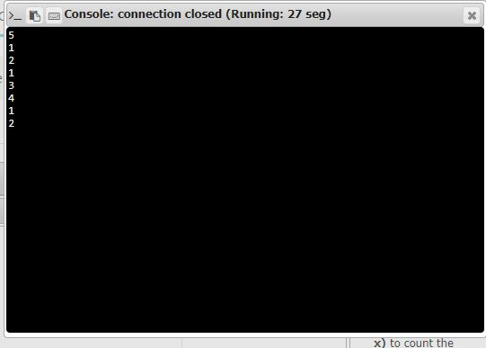

Result:

Thus the program has been successfully executed and the output is verified.